(Appendix G – Information and Consent Form for Parent Participants to Participate in a Research Study)

Title of the Study:

Wizard of Oz study using humanoid NAO in “An Intelligent Prompting System to Help Teach Self-Care Skills to Children with Autism Spectrum Disorder”

Investigators:

Faculty Supervisor: Dr. Alex Mihailidis, Occupational Science and Occupational
(Principal Investigator) therapy (University of Toronto) and Clinical Integrative Biology
(Sunnybrook Health Sciences Centre)
Ph: (416) 946-8565
Email: alex.mihailidis@utoronto.ca

Student Researcher: David Xue, M.A.Sc. Candidate
(“Investigator”) University of Toronto
Ph: (416) 946-8573
Email: di.xue@mail.utoronto.ca

Research Coordinator: Jennifer Boger, Research Manager, University of Toronto
Ph: (416) 946-8573
Email: jen.boger@utoronto.ca

Bing Ye, Research Assistant, University of Toronto
Ph: (416) 597-3422 ext. 7910
Email: bing.ye@uhn.ca

Please note that the security of e-mail messages is not guaranteed. Messages may be forged, forwarded, kept indefinitely, or seen by others using the internet. Do not use e-mail to discuss information you think is sensitive. Do not use e-mail in an emergency since e-mail may be delayed.

Introduction

You are being asked to take part in a research study. Please read the information about the study presented in this form. The form includes details on study’s risks and benefits that you should know before you decide if you would like to take part. You may take up to a week to decide whether or not to participate. You should ask the study staff to explain anything that you do not understand and make sure that all of your questions have been answered before signing this consent form. Before you make your decision, feel free to talk about this study with anyone you wish including your friends, family, and family doctor. Participation in this study is voluntary.

Background/Purpose of the Study

Autism Spectrum Disorder (ASD) is recognised as the most common neurological disorder affecting children. One of the greatest concerns of parents of children with ASD is whether their child will live a safe, productive, and independent life. Independent living starts with the ability to master behaviours, such as self-care, something that many children with ASD have difficulties learning to do.

We are inviting you and your child to participate in a research study that will test a new robot-based system that has been built to help children with ASD learn how to complete activities of daily living. The example activity that will be used is hand washing. The system is designed to monitor your child as he or she goes about the task of hand washing and the robot to provide audio and gestural cues if (and only if) your child forgets what step of the activity comes next, unnecessarily repeats a step, or completes a step in hand washing out of order.

The purpose of the study is to explore the use of socially assistive humanoid robot in prompting children with ASD through hand-washing activity. Specifically, we want to explore the different kinds of interactions between children and the robot. If the robot will indeed promote better engagement and compliance during hand-washing tasks, the results of the study could have far-reaching implications for children with ASD and their families and caregivers.

We will be recruiting six children with ASD and their parent (either mom or dad) for the study.

You are being asked to participate because you are a parent of a child with ASD who has experience caring for children with ASD and is familiar with the issues associated with this relationship. Any comments or concerns that you and/or your child have during this pilot study will be used to improve the next version of the system. The data collected here will also help us determine if the humanoid robot, in its current state, can help teach your child to wash his/her hands. Through yours and your child’s feedback and trial data, we hope to build a friendly and effective humanoid robot system that can be available to children with ASD.

Description of the Research Study

Study Setup
If you agree to participate, we will invite you and your child to the washroom laboratory located in the HomeLab of Toronto Rehabilitation Institute (TRI), where the robotic system is installed. The system will be set up near the sink, and consists of a robot, an LCD screen, an overhead camera, a scene camera, and a Kinect camera. A picture of the system setup can be seen in Figure 1.

The robot is a small half-torso humanoid robot and will be screw mounted on the sink countertop at the top left corner (please see Figure 1(a)). The robot will deliver the audio-gesture cues to your child during his/her hand washing. The LCD screen will display a virtual avatar, which is a pre-recorded video version of the robot. The virtual avatar will deliver the same prompts as the robot. The virtual avatar will be compared against the robot for exploring the effects on your child’s engagement and compliance in performing the hand-washing tasks. The LCD screen will be screw mounted in a similar manner on the sink table to replace the robot when the virtual avatar is used as the prompting agent (please see Figure 1(b)). The robot and the virtual avatar will be remotely controlled through an interface running on a touchscreen laptop. The laptop is operated by a researcher, like myself, in a room adjacent to the washroom. The robot will avoid physically contacting your child and will remain motionless when your child is touching it. The cameras and the microphones on the cameras will record your child’s hand-washing performance and how he/she performs during the task.
a)
b)
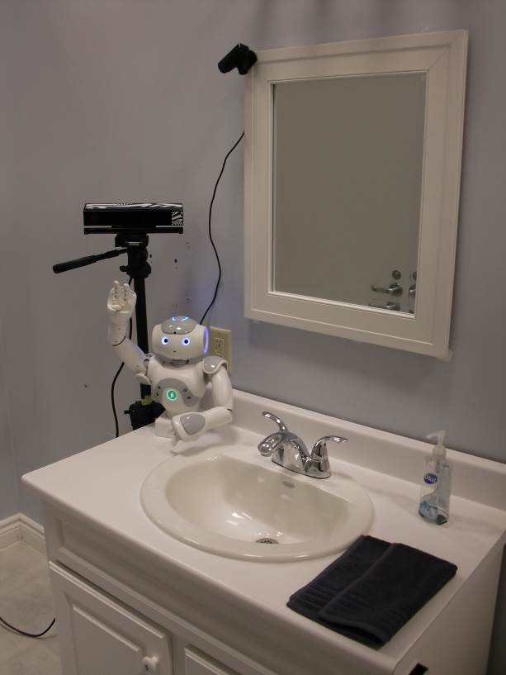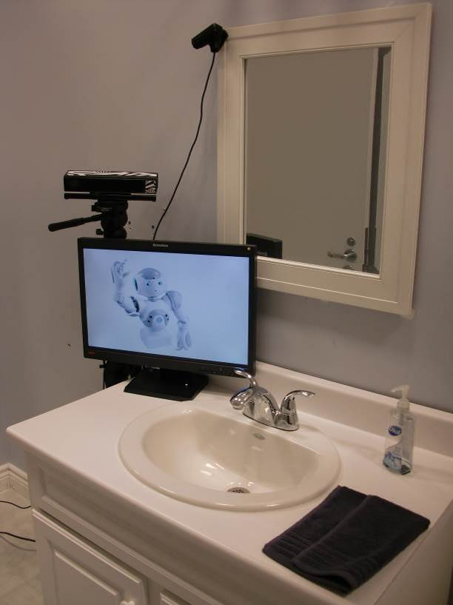
Figure 1 The HomeLab washroom setup with the prompting system: a) with the robot as a prompting agent; b) with the virtual avatar as a prompting agent.

b)
a)
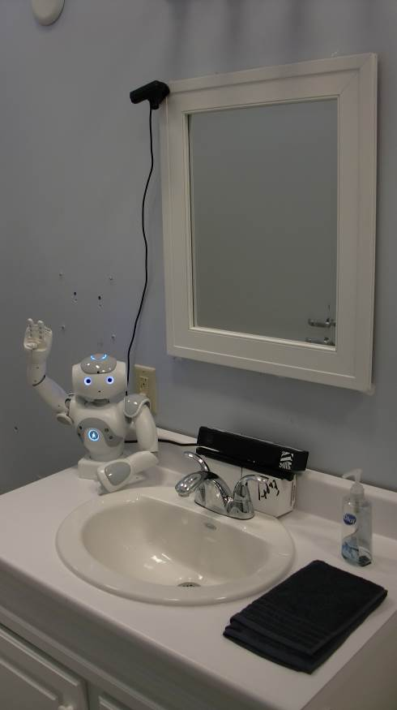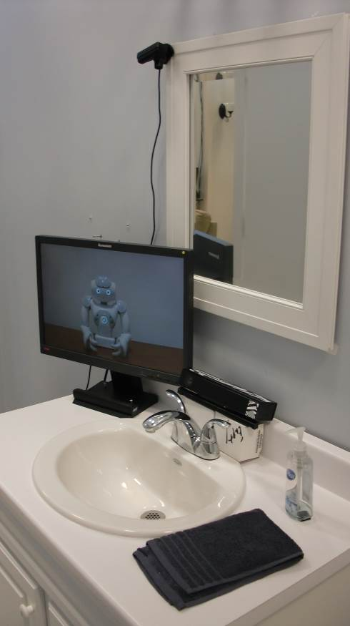
Figure 2 The HomeLab washroom setup with the prompting system: a) with the robot as a prompting agent; b) with the virtual avatar as a prompting agent.

Study Visits
You and your child will visit the HomeLab once a week with a total of six visits. It will take about an hour to an hour and a half for each visit.

What will Happen During the Study
Prior to the first visit, you will be asked to complete the entrance survey for your child’s basic demographics and your child’s hand-washing ability level. For consistency, we encourage the parent who has completed the entrance survey to accompany the child through all six visits and to complete the other surveys.

Your child will be asked to wash his/her hands eight times for every visit. There will be a short break between the fourth and the fifth hand-washing activity to prevent fatigue at each visit. Your child may also take breaks at any time if needed. The break will last as long as the child needs until he/she is willing to continue the hand-washing activities. If you feel the need, you and your child may leave and come back to finish the activities another day. For the first two visits (Baseline Phase), your child will be asked to wash his/her hands as independently as possible. You will be asked to help your child and/or to give reinforcements whenever you feel necessary. A researcher, like myself, will be in an adjacent room out of the view of you and your child to observe the activity. For the next four visits (Intervention Phase), you and the researcher will be in the adjacent room to observe your child when he/she is washing hands. Your child will be assisted to wash his/her hands by the robot in two visits and assisted by the virtual avatar in the other two visits. The two visits are one after another for the robot and for the avatar. The order of whether your child will be assisted by the robot or by the virtual avatar will be chosen randomly. This means that they are put into a group by chance. It is like flipping a coin. You may be asked to help your child through the hand-washing task(s) as needed.

In the last visit, besides your child’s hand-washing activity, you will also be asked to complete the post-intervention survey and the exit survey. These surveys will provide us your feedback regarding the system and the study. A variation of the post-intervention survey will be verbally administered by the researcher to your child as well to capture his or her views of the system.

During all phases of the hand-washing activities, you and your child will be audio recorded. This is to help us determine the verbal interactions that your child may have with the robot/virtual avatar as well as the verbal interactions between you and your child during the hand washing. Your child will also be discretely videotaped from the overhead, scene, and Kinect camera during the task of hand-washing. This is for data analysis purpose. At certain times you will also be videotaped. For example, if your child needs your assistance while washing hands, then you will be videotaped while you assisting them.

Potential Harms/Risks

We know of no harm/risk that will occur to you or your child as a result of participation in this study. The device being tested through this research is non-evasive; there are no safety concerns associated with the use of the prompting system. The small humanoid robot in close proximity with the children is remotely controlled and tightly monitored by the researcher to prevent physical contact with the children and to prevent it from moving if the children initiate physical contacts. An emergency stop button implemented in the controlling software of the interface is available to instantly disable all motor forces when needed. Both the robot and the LCD screen will be screw mounted on the sink table to prevent it from moving.

Potential Benefits

Through participation in this study, your child may gain some independence in the task of hand washing. Moreover, the data gained from this study will be invaluable in the creation of a system to help children with ASD learn activities of daily living. This system has the potential to help children with ASD to become more independent in a friendly and self-initiated way.

The results of this study will be presented at academic conferences and published in an academic journal. The research team can provide you with a copy of the paper upon request.

Confidentiality

Any of your personal information (information about you and your health that identifies you as an individual) collected or obtained, whether you choose to participate or not, will be kept confidential and protected to the fullest extent of the law. All personal information collected will be kept in a secure location. The study staff and the Toronto Rehabilitation Institute Research Ethics Board will have access to your personal information for purposes associated with the study, but will only be allowed to access your records under the supervision of the Principal Investigator Alex Mihailidis and will be obligated to protect your privacy and not disclose your personal information.

All survey data will be stored in a locked cabinet different from where the consent forms are stored with access only to the research team.

Both the video and audio data will be stored temporarily on the laptop’s hard drive during you and your child’s visit. The data will be encrypted and transferred to the TRI servers as soon as after the visit. The portable devices, such as USB sticks, will be used to transfer the data to the TRI servers. All data stored on the TRI servers will be password protected. The data on the laptop’s hard drive and the portable devices will then be purged immediately after transfer. All audio and video files will be kept strictly confidential within the research team and will not be shared with others without your express permission.

When the results of this study are published, you and your child’s identity will not be disclosed. The data for this study will be retained for seven years after study closure. All data will be destroyed seven years after the study closure.

Participation

You and your child’s participation in this study is voluntary. You may decide not to be in this study, or to be in the study now, and then change your mind later. You may leave the study at any time without affecting your future medical treatment or provision of health care or employment. We will give you new information that is learned during the study that might affect your decision to stay in the study.

You may refuse to answer any question you do not want to answer in the survey by saying “pass”.

The AI and Robotic Team intends to claim sole ownership of any results that would come from this study. You and your child will not receive any financial benefit that might come from the results of this study.

Withdrawal from Study

If you decide to leave the study, you have the right to request withdrawal of information collected about you. Should you choose to withdraw from the study you are encouraged to contact David Xue at (416) 946-8573 or di.xue@mail.utoronto.ca immediately.

If you leave the study, the information that was collected before you left the study will still be used in order to help answer the research question. No new information will be collected without your permission.

Costs and Reimbursement

There are no costs to participate in this study. You will be reimbursed $200 upon completion of the study. You will be able to withdraw from the study at any time. The honorarium will be adjusted to be proportionate to the number of visits completed (e.g. completing 3 visits means the participated child will receive $100 ($200 * 3 / 6 = $100)). The compensation will be given to each participating child. For example, if a family has two children with ASD and they are both qualified for the study, the parent will receive $400 upon their completion of the study. You and your child will not be reimbursed for transportation and meals.

Rights as a Participant

If you are harmed as a direct result of taking part in this study, all necessary medical treatment will be made available to you at no cost.

By signing this form you do not give up any of your legal rights against the investigators, sponsor or involved institutions for compensation, nor does this form relieve the investigators, sponsor or involved institutions of their legal and professional responsibilities.

Conflict of Interest

There are no conflicts of interest for any of the investigators in this study. Researchers have an interest in completing this study. Their interests should not influence your decision to participate in this study.

Questions about the Study

If you have any questions, concerns or would like to speak to the study team for any reason, please contact David Xue at (416) 946-8573 or di.xue@mail.utoronto.ca

If you have any questions about your rights as a research participant or have concerns about this study, call the Chair of the University Health Network Research Ethics Board (UHN REB) or the Research Ethics office number at 416-581-7849. The REB is a group of people who oversee the ethical conduct of research studies. The UHN REB is not part of the study team. Everything that you discuss will be kept confidential.

You will be given a signed copy of this consent form.

Consent

This study has been explained to me and any questions I had have been answered.
I know that I may leave the study at any time. I agree to the use of my information as described in this form. I agree to take part in this study.

Print Name of Parent/Legal Guardian |  | Date |  | Parent/Legal Guardian’s signature

My signature means that I have explained the study to the participant named above. I have answered all questions.

Print Name of person who obtained consent |  | Date |  | Signature

Printed Witness’ name (if the parent/legal guardian does not read English) |  | Date |  | Witness’ signature

Video Recording Consent

In addition, I agree to have my child videotaped/photographed during this study. I also agree for any photograph/video to be used for (check all that apply):

Other research studies on the same topic

Teaching and demonstration at the University of Toronto

Teaching and demonstration outside the University of Toronto

Not to be used for any purpose other than this research study

In agreeing to the use of my photograph/video for the above purposes, I understand that my identity will be made secret by blocking out my face and any other distinguishing features. I also have the right to withdraw my permission at any time.
Print Name (parent) |  | Signature |  | Date
Person who obtained consent |  | Signature |  | Date
If the consentee does not read English:

Print Witness’ name |  | Signature |  | Date

